Worksheet 4 Graph traversal algorithms

Task 1

1. The algorithm for a depth-first traversal is given below, together with the definition of the graph that has just been traversed in the PowerPoint presentation, held in an adjacency list implemented as a dictionary data structure. The main program calls the subroutine , passing the first node and the empty list of visited nodes as parameters

GRAPH = { "A":["B","D","E"], "B":["A","C","D"], "C":["B","G"], "D":["A","B","E","F"], "E":["A","D"] , "F":["D"], "G":["C"]}
visitedList = [] #an empty list of visited nodes

SUB dfs(graph, currentVertex, visited)
append currentVertex to list of visited nodes
#check neighbours of currentVertex
FOR vertex in graph[currentVertex]
IF vertex NOT IN visited THEN
dfs(graph, vertex, visited)
#system stack will automatically store return address, parameters and local variables
ENDIF
ENDFOR
RETURN visited
ENDSUB

#main program
traversal = dfs(GRAPH, "A", visitedList)
OUTPUT "Nodes visited in this order: ", traversal

(a) Which vertices are referred to in the FOR statement the first time it is executed?
“B”, “D” and “E”. This is the list of vertices that will be found for the key “A” in the dictionary definition of the graph

(b) The subroutine is recursive. What are the values of vertex and visited the first time the recursive call is made in the subroutine?
“B” and [“A”] (“A” was added in the statement
“append currentVertex to list of visited nodes”)

(c) Why is there no reference to pushing and popping items on and off the stack in this algorithm?
The system stack will automatically store return address, parameters and local variables so it is not necessary to do this within the program

(d) What order are the nodes visited in using this traversal algorithm?
A B C G D E F

2. A recursive routine can be used to perform a depth-first search of the graph that represents a maze to test if there is a route from the entrance 1 to the exit 5.
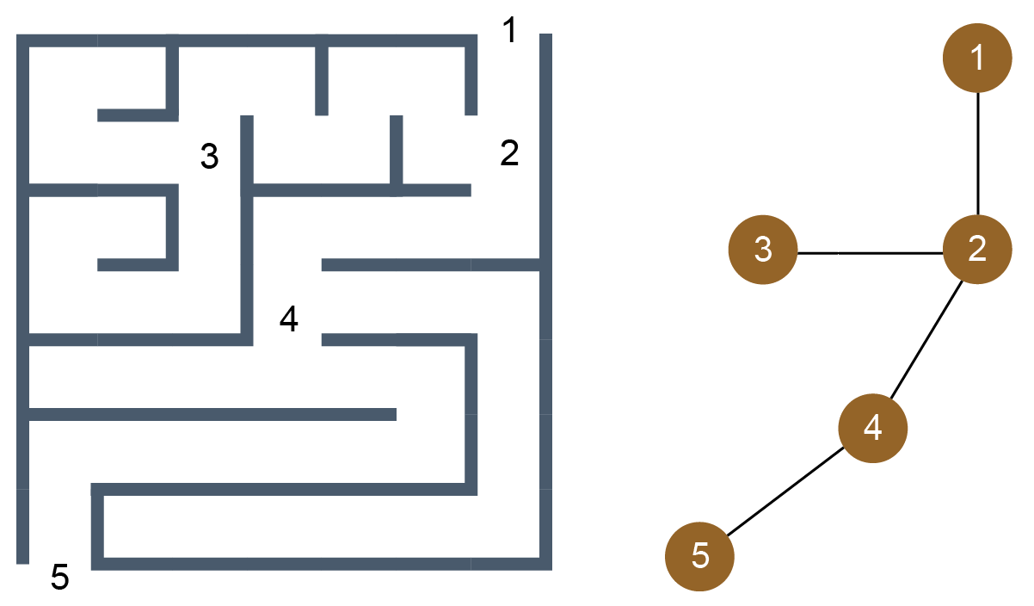
The routine is shown below. It has two parameters, v (the current vertex) and endV (the exit vertex)
PROCEDURE DFS(v, endV)
discovered[v] True
IF v = endV THEN found True
FOR each neighbour u of v
IF discovered[u] = False THEN DFS(u, endV)
ENDFOR
completelyExplored[v] True
END PROCEDURE
Complete the trace table below to show how the discovered and completelyExplored flag arrays and the variable found are updated by the algorithm when it is called using DFS.
 |  |  |  |  | discovered |  |  |  |  | completelyExplored
 | Call | V | U | endV | [1] | [2] | [3] | [4] | [5] | [1] | [2] | [3] | [4] | [5] | Found
1 |  | - | - | 5 | F | F | F | F | F | F | F | F | F | F | F
2 | DFS(1,5) | 1 | 2 | 5 | T | F | F | F | F | F | F | F | F | F | F
3 | DFS(2,5) | 2 | 1 | 5 | T | T | F | F | F | F | F | F | F | F | F
4 |  |  | 3 | 5 | T | T | F | F | F | F | F | F | F | F | F
5 | DFS(3,5) | 3 | 2 | 5 | T | T | T | F | F | F | F | T | F | F | F
6 | DFS(2,5) | 2 | 4 | 5 | T | T | T | F | F | F | F | T | F | F | F
7 | DFS(4,5) | 4 | 2 | 5 | T | T | T | T | F | F | F | T | F | F | F
8 | DFS(4,5) |  | 5 | 5 | T | T | T | T | F | F | F | T | F | F | F
9 | DFS(5,5) | 5 | 4 | 5 | T | T | T | T | T | F | F | T | F | T | T
10 | DFS(4,5) | 4 | - | 5 | T | T | T | T | T | F | F | T | T | T | T
11 | DFS(2,5) | 2 | - | 5 | T | T | T | T | T | F | T | T | T | T | T
12 | DFS(1,5) | 1 | - | 5 | T | T | T | T | T | T | T | T | T | T | T
Additional question
3. Here is another graph.
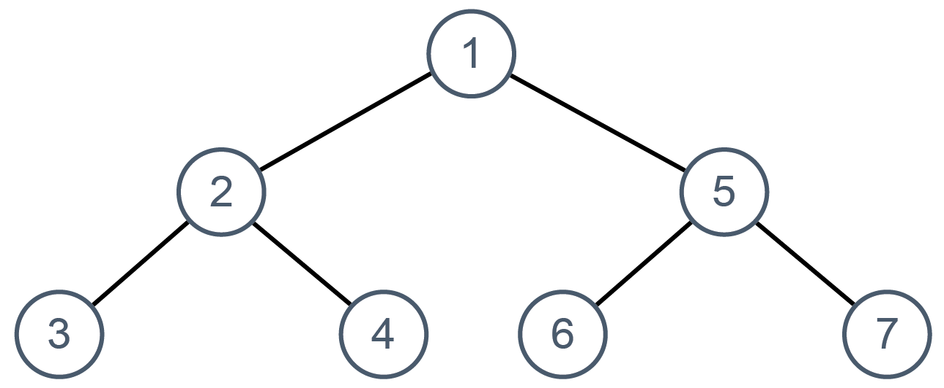

Using the same algorithm as above, complete the trace table below to show how the discovered and completelyExplored flag arrays and the variable found are updated by the algorithm when it is called using DFS.
 |  |  |  | discovered |  |  |  |  |  |  |  | completelyExplored
Call | v | u | endV | [1] | [2] | [3] | [4] | [5] | [6] | [7] | [1] |  | [2] | [3] | [4] | [5] | [6] | [7] | found
 | - | - | 7 | F | F | F | F | F | F | F | F |  | F | F | F | F | F | F | F
DFS(1,7) | 1 | 2 | 7 | T
DFS(2,7) | 2 | 1 | 7 |  | T
 |  | 3 | 7
DFS(3,7) | 3 | 2 | 7 |  |  | T |  |  |  |  |  |  |  | T
DFS(2,7) | 2 | 4 | 7
DFS(4,7) | 4 | 2 | 7 |  |  |  | T |  |  |  |  |  |  |  | T
DFS(2,7) | 2 | - | 7 |  |  |  |  |  |  |  |  |  | T
DFS(1,7) | 1 | 5 | 7
DFS(5,7) | 5 | 1 | 7 |  |  |  |  | T
 | 5 | 6 | 7
DFS(6,7) | 6 | 5 | 7 |  |  |  |  |  | T |  |  |  |  |  |  |  | T
DFS(5,7) | 5 | 7 | 7
DFS(7,7) | 7 | 5 | 7 |  |  |  |  |  |  | T |  |  |  |  |  |  |  | T | T
DFS(5,7) | 5 | - | 7 |  |  |  |  |  |  |  |  |  |  |  |  | T
DFS(1,7) | 1 | - | 7 |  |  |  |  |  |  |  | T

Task 2
4. The algorithm for the breadth-first search is given below, together with the adjacency list implemented as a dictionary data structure which defines the graph.

GRAPH = {
"A": {"colour": "White", "neighbours": ["B", "D", "E"]},
"B": {"colour": "White", "neighbours": ["A", "D", "C"]},
"C": {"colour": "White", "neighbours": ["B", "G"]},
"D": {"colour": "White", "neighbours": ["A", "B", "E", "F"]},
"E": {"colour": "White", "neighbours": ["A", "D"]},
"F": {"colour": "White", "neighbours": ["D"]},
"G": {"colour": "White", "neighbours": ["C"]}
}

SUB bfs(graph, vertex)
queue [] #an empty queue
visited [] #an empty list of visited nodes
enqueue vertex
WHILE queue NOT empty
dequeue item and put in currentNode
set colour of currentNode to "Black"
append currentNode to visited
FOR each neighbour of currentNode
IF colour of neighbour = "White" THEN
enqueue neighbour
set colour of neighbour to "Grey"
ENDIF
ENDFOR
ENDWHILE
RETURN visited
ENDSUB
#main
visited bfs(GRAPH, "A")
OUTPUT "List of nodes visited: ", visited

- Draw the graph. In what order are the vertices visited in this traversal?
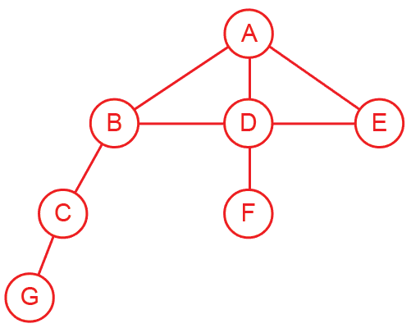
A B D E C F G
(b) Is this algorithm iterative or recursive?
Iterative
(c) What is the state of the queue before the WHILE loop is entered for the first time?
It contains A, which will be the first vertex visited
(d) What does the colour of a particular node signify?
White means not visited,
Grey means visited but not fully explored – the vertex has been queued for further processing
Black means dequeued, added to the visited list and fully explored.

